Name: __________________
Absolute Dating
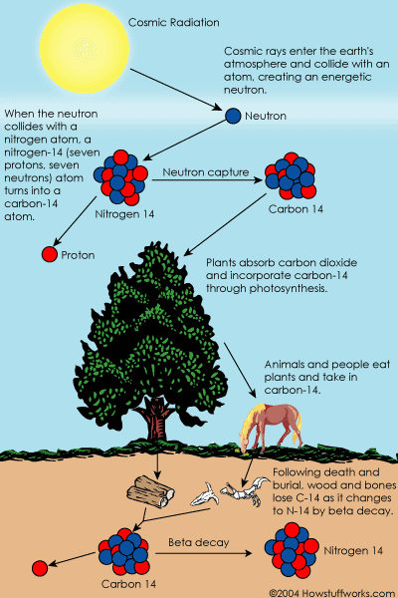
How Carbon-14 is made
Cosmic rays enter the earth's atmosphere in large numbers every day. For example, every person is hit by about half a million cosmic rays every hour. It is not uncommon for a cosmic ray to collide with an atom in the atmosphere, creating a secondary cosmic ray in the form of an energetic neutron, and for these energetic neutrons to collide with nitrogen atoms. When the neutron collides, a nitrogen-14 (seven protons, seven neutrons) atom turns into a carbon-14 atom (six protons, eight neutrons) and a hydrogen atom (one proton, zero neutrons). Carbon-14 is radioactive, with a half-life of about 5,700 years.

Carbon-14 in Living Things
The carbon-14 atoms that cosmic rays create combine with oxygen to form carbon dioxide, which plants absorb naturally and incorporate into plant fibers by photosynthesis. Animals and people eat plants and take in carbon-14 as well. The ratio of normal carbon (carbon-12) to carbon-14 in the air and in all living things at any given time is nearly constant. Maybe one in a trillion carbon atoms are carbon-14. The carbon-14 atoms are always decaying, but they are being replaced by new carbon-14 atoms at a constant rate. At this moment, your body has a certain percentage of carbon-14 atoms in it, and all living plants and animals have the same percentage.
Dating a Fossil
As soon as a living organism dies, it stops taking in new carbon. The ratio of carbon-12 to carbon-14 at the moment of death is the same as every other living thing, but the carbon-14 decays and is not replaced. The carbon-14 decays with its half-life of 5,700 years, while the amount of carbon-12 remains constant in the sample. By looking at the ratio of carbon-12 to carbon-14 in the sample and comparing it to the ratio in a living organism, it is possible to determine the age of a formerly living thing fairly precisely.

Radioactive Decay: A Sweet Simulation of Half-Life
Name:_________________________________________
In this simulation, you will use small pieces of candy marked on one side. They will be your “nuclei.” You also need a paper towel on which to place your “nuclei.”
Toss  (# of half lives) | Number of radioactive nuclei | Prediction for next toss
0
1
2
3
4
5
6
7
8
9

Procedure

1. Count your nuclei (candy). Write that number in the data table under the heading “Number of Radioactive Nuclei.” In the column marked “Prediction for Next Toss” write the number of radioactive nuclei you think you will have with your next toss. (Radioactive nuclei will be those candies with the marked side down.)
2. Place your “nuclei” in a paper cup, cover and shake the cup. Pour the “nuclei” onto your paper towel. Separate the “nuclei” into two piles, one with the marked side up and the other with the marked side down. Count the number of “nuclei” in each pile. On your data table, record the number of “radioactive nuclei” candies with the marked side down. Predict how many radioactive “nuclei” you will have after the next toss.
3. Return only the radioactive “nuclei” to your paper cup. (You decide what to do with the “decayed nuclei,” or those with the marked side up.)
4. Continue this process until there are no radioactive “nuclei” left. Add more rows to your data table, if needed.

Analysis:
1. Using the pooled data, prepare a graph by plotting the number of radioactive “nuclei” on the y-axis and the number of tosses, which we will call half-lives, on the x-axis.
2. How good is our assumption that half of our radioactive “nuclei” decay in each half-life? Explain.
____________________________________________________________________________________
____________________________________________________________________________________
____________________________________________________________________________________
____________________________________________________________________________________
3. If you started with a sample of 600 radioactive nuclei, how many would remain undecayed after three half-lives? (math below) ___________________________________________________________________________
4. If 175 undecayed nuclei remained from a sample of 2800 nuclei, how many half-lives have passed? (math below)
____________________________________________________________________________________
5. Why did we pool the class data? How does this relate to radioactive nuclei?
____________________________________________________________________________________
____________________________________________________________________________________
____________________________________________________________________________________
6. How many half-lives would it take for 6.02 x 10²³ nuclei to decay to 6.25% (0.376 x 10²³) of the original number of nuclei? (math below)
____________________________________________________________________________________
____________________________________________________________________________________
7. Is there any way to predict when a specific piece of candy will land marked side up or “decayed?” If you could follow the fate of an individual atom in a sample of radioactive material, could you predict when it would decay? Explain.
____________________________________________________________________________________
____________________________________________________________________________________
____________________________________________________________________________________
____________________________________________________________________________________
8. Strontium-90 has a half-life of 28.8 years. If you start with a 10-gram sample of strontium-90, how much will be left after 115.2 years? Justify your answer with math below.
____________________________________________________________________________________
____________________________________________________________________________________
____________________________________________________________________________________
9. What do we mean by half-life? With what kinds of materials do we use this term?
____________________________________________________________________________________
____________________________________________________________________________________
____________________________________________________________________________________

USE THE SPACE HERE TO DO SOME MATH
Half-life nuclei
Half-life nuclei
Half-life nuclei
Half-life nuclei

Using the pooled data, prepare a graph by plotting the number of radioactive “nuclei” on the y-axis and the number of tosses, which we will call half-lives, on the x-axis.

Pool the class data by summing the number of radioactive “nuclei” of all the class groups for each toss below.
Toss | Number of radioactive nuclei
Before the first toss
1
2
3
4
5
6
7
8
9
10

